

Sultan Qaboos University

College of science

COMP3700: Introduction to Web Computing

**Knight Creativity**

**Group Project Members:**

* Laith Alhilali 141644
* Shathan AlHajri 140688
* Hamza Alaamri 142547

**Part one 3**

**4.Interviews 3**

**5. Main Objectives of the website 3**

**6 references . 4**

**7. Website Contents 5**

**8. website structure 6**

**9. Website logo 7**

**10. data base 7**

**11. web hosting 9**

**12. Google sites Web site 9**

**13. How a Car Parts and Auctions Website Impacts Individuals and Society. 10**

**Part two 12**

1. Overview Structure of the Website: 12

2. Description of the pages: 12

3. CSS Style and Bootstrap usage: 17

4. hyperlink 18

5. table of contribution 18

# Part one

## 4.Interviews

Car Parts Seller

• Name: Abdullah

• Role: Supplier of car parts for various make and models.

1- Q: How do you sell your car parts online?

A: I usually rely on other websites like eBay, but I am searching for a more specialized website where customers can readily identify the parts I sell.

2- Q: What features do you want in an auto parts listing system?

A: I need the group upload capability to insert several parts at once, since I have a lot of things. Being capable of categorizing components by car make, model, and year is important for quick search.

3- Q: Are you interested in conducting discounts?

A: Yes, I'd like discounts on specific products, particularly around holidays or sales events.

Requirements Gathered:

• Bulk upload tool for adding multiple car parts at once.

• Filtering system to categorize parts by make, model, and year.

• Offering discounts and sales.

## 5. Main Objectives of the website

* Make it easier for people to know which kind of service your car needs
* Saves your time by booking an online service
* Stores your car documents and information in one place
* Worldwide auction with various features
* Notify you before your service

## 6 references .

This is a reference for similar websites:

There are some websites that have a similar idea from what our plan is, these two websites are related to our idea:

1. Online garage

<https://www.avondaleautorepair.com/>

1. Online car auction

<https://www.copart.com/?srsltid=AfmBOopmpZrLUlEWcNwEH69BhZNNQAhXw7H8CXqNp7CH0WDBg1iG29VR>

## 7**. Website Contents**

1. **Home Page**

**Description:**

* The home page will serve as the default and front page of the website, introducing users to the website's primary functionalities and services.
* It will briefly outline the available services, such as car diagnostics, service booking, document storage, and the auction platform.
* A section for frequently asked questions will address common concerns such as "How do I know which service my car needs?" and "How does the auction process work?"

**2. Car Services Page**

**Description:**

* A variety of auto services, including diagnostics and both minor and major repairs, will be offered on this page.
* A straightforward tutorial will walk users through determining what kind of maintenance their vehicle might need. We'll answer questions like "When should I get my car checked?" and "What is a minor service?"
* Additionally, the page will have a service booking function that lets users make an appointment for the service they require.

**3. Health Check Calculator Page (Car Edition)**

**Description:**

* Users can input their car's mileage, model, age, and usage level. Based on this data, the page will provide suggestions for maintenance (e.g., oil changes, tire rotations, or major servicing).
* The calculator could also indicate the car's current health status and recommend whether it’s ready for an auction or needs service first.

**4. About Us Page**

**Description:**

* The founders and contributors who made the platform possible will be highlighted on this page, which will also tell the story of how and why the website was made.
* It will also explain the mission: to make car management simple by offering a full-featured platform for services, document storage, and auctions.

**5. Contact Us Page**

**Description:**

* This page will offer users a way to get in touch with the team. It will include contact information such as email addresses, and phone numbers.
* A simple contact form will allow users to send inquiries or feedback directly through the site.

## 8. website structure



## 9. Website logo



this is our website logo, it shows what is our project about which is an online garage that helps

people with any service they need with their car, our website logo have a car design and our

website name.

## 10. data base

Our website has 3 types of data to be maintained: customer data, vehicle data, service data. Customer data contains information about the customer (name, phone number, email), the customer vehicle information(manufacturer, model), and the customer’s service history. The vehicle data includes all the vehicles available for the auctions with their information (manufacturer, model,year, mileage, price, chassis number). Service data is all the services that the garage offers for the vehicle ( service type, description, price) .

1. Customer data

| **Data** | **Data type** |
| --- | --- |
| Name | String |
| Phone number | Integer |
| Email | String |
| Car manufacturer | String |
| Car model | String |

1. Vehicle data

| **Data** | **Data type** |
| --- | --- |
| manufacturer | String |
| model | String |
| year | Integer |
| mileage | Integer |
| price | Float |
| chassis number | String |
|  |  |
|  |  |

1. Service data

| **Data** | **Data type** |
| --- | --- |
| Service type | String |
| Description | String |
| Price | Float |

## 11. web hosting

. We carefully considered the benefits and drawbacks of each web hosting company after analyzing several of them, including InfinityFree, Byet.Host, AwardSpace, FreeHosting, and InterServer. Although a lot of these businesses provide a variety of services, we discovered that some either don't have a free subscription plan or do have one with few features and obtrusive ads.

We gave it some thought before deciding to use InfinityFree to host our website. One major advantage over other free hosting providers is that this one offers unlimited disc space and bandwidth. InfinityFree is a great fit for our website's needs because it offers ad-free hosting as well as complete support for technologies like PHP, CSS, JavaScript, and MySQL databases. InfinityFree was the best option for our project because of its rich feature set, free hosting, and dependability.

## 12. Google sites Web site

<https://sites.google.com/student.squ.edu.om/knightscreativity/home>

## 13. How a Car Parts and Auctions Website Impacts Individuals and Society.

For People:

1. Let's say you need a spare part for your car. Instead of searching from store to store, just go online, search and you'll find what you need right from home. That's a lot easier, isn't it? Additionally, online auctions can be a great way to get a car at a good price, especially if you're looking for something rare or just want to get a deal.

For Society:

1. It's not just about providing convenience to people, there's a greater impact as well. When people buy used car parts or used cars, it helps reduce the car waste. Instead of throwing the unused parts or cars people can reuse them and that will help the environment and let’s not forget car enthusiasts this kind of site brings them together, creating a little community of people who love fixing up cars.
2. **Are the Parts and Cars Legit?**  
   One of the big things about selling car parts or cars is making sure they’re real and in good condition. If someone buys a part that’s fake or broken, it could lead to big safety problems when they’re driving. That’s a serious issue!
   * **How to Deal with It**: The site needs to work only with trusted sellers and make sure they’re selling what they say they are. There should be clear descriptions and, if something’s wrong, buyers should be able to return them easily. Warranties help too, so people know they’re covered.
3. **Avoiding Scams in Auctions**  
   Auctions can be tricky because people might try to cheat—like bidding fake amounts to push up the price or lying about the condition of a car. If that happens, buyers end up paying more than they should or getting a car that’s not what they expected.
   * **How to Deal with It**: The website should verify both buyers and sellers, making sure everyone’s playing fair. They should also provide good info on the cars, like inspection reports, so buyers know what they’re getting. And there should be tools in place to watch for any shady activity and stop it before it becomes a problem.
4. **Thinking About the Environment**  
   While it’s great that people are buying used parts (which is good for the planet), the site also needs to think about the kind of cars they’re selling. If they push a lot of old, gas-guzzling cars, it’s not so great for the environment.
   * **How to Deal with It**: The site could highlight more eco-friendly cars or parts—like hybrid or electric vehicles—and share tips on how fixing up a car instead of buying a new one is better for the environment. Also, they should think about ways to ship parts that don’t create a lot of pollution.

# Part two

## Overview Structure of the Website:

* The website is organized into several core sections to address various user needs related to car services and auctions:
* Home Page: Introduction of the website and gives access to all features.
* Part: E-commerce section for spare parts.
* Auctions: Platform for bidding on used cars.
* Support: Facilitates communication with the team.
* About us: Introduction page about Knight Creativity
* Login Page: Allows users to store car documents, track service history, and receive reminders.

## Description of the pages:

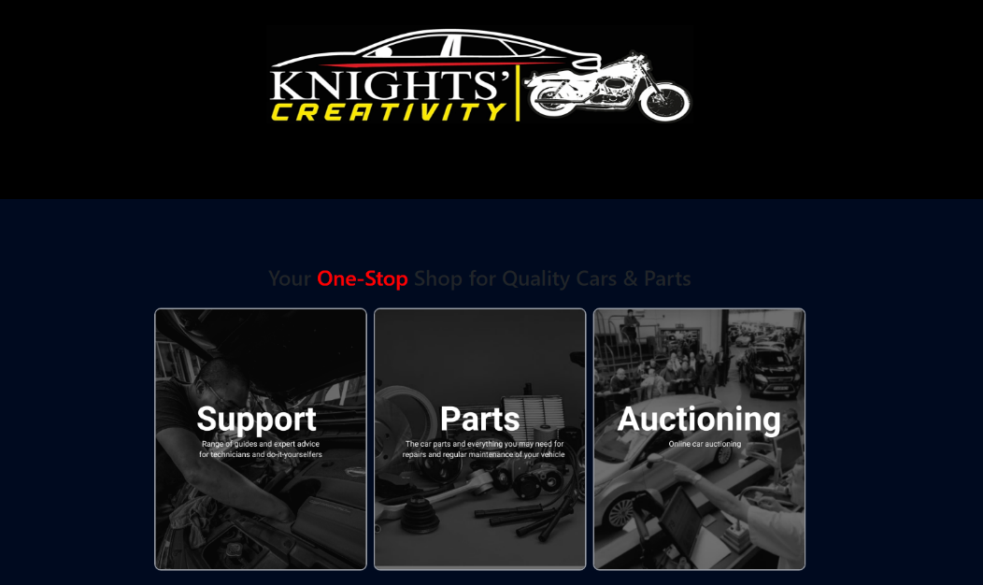

1. Home Page:

* Represents the brand identity of the website.
* **Support**: Provides access to guides and expert advice on vehicle maintenance and troubleshooting.
* **Parts**: Directs users to the spare parts store for purchasing car components.
* **Auctioning**: Links to the car auction platform for buying and selling vehicles.

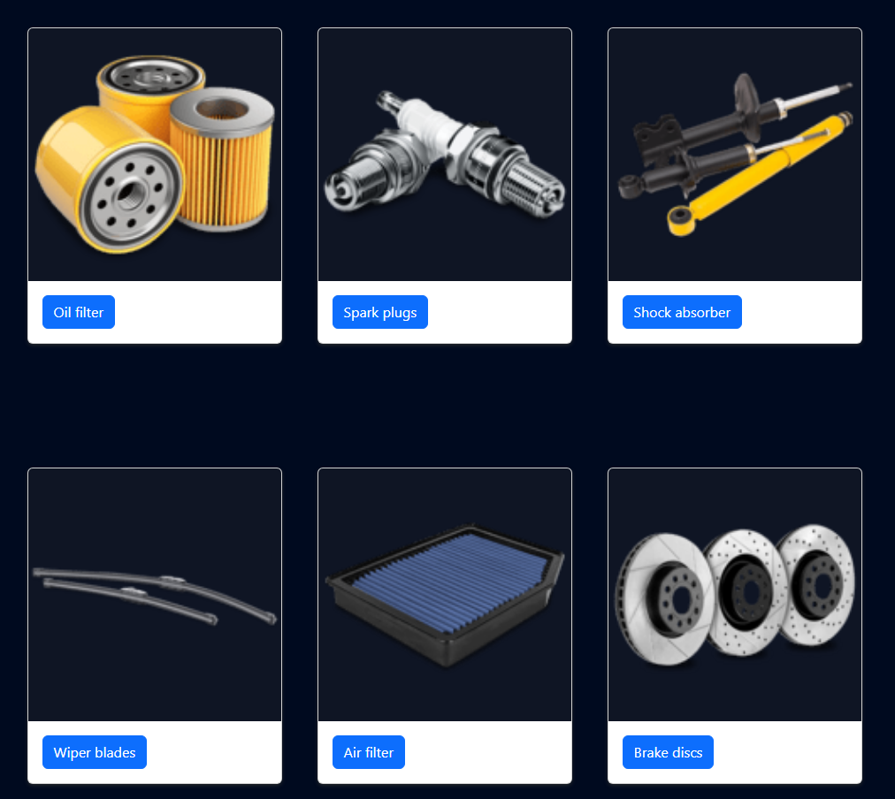

1. Parts Page:

* Showcase various car parts available for purchase.
* Each part is displayed with the description of it.

1. Auction Page:

* Display a list of cars available for bidding.
* Each car card includes:
* Car Image: Visual representation of the car.
* Model and Year: Identifies the car's make and year.
* Starting Bid: Initial bidding price.
* Description: Highlights of the car's features and specifications
* Interactive form allowing users to place bids.
* Fields include:
* Name: User’s name.
* Email: Contact information.
* Car Model: Car for which the bid is placed.
* Your Bid: Amount the user wishes to bid.

1. About Us Page:

* Our Mission and Bried Description of the point of this site,
* Knight Creativity Logo
* Milestone Table

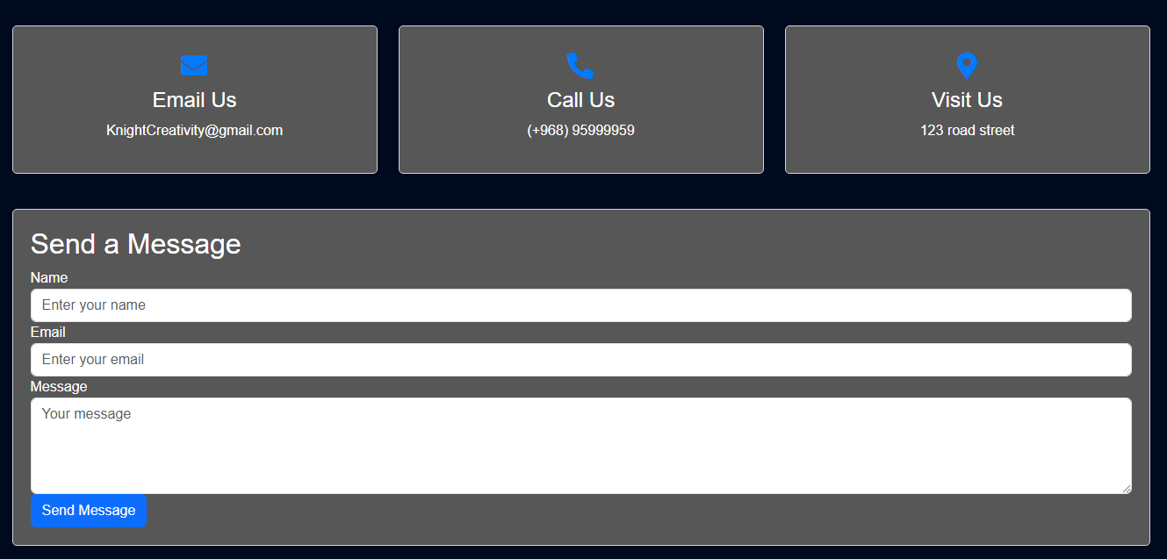

1. Contact Us Page:

* Contact Us Information provides an email, phone number and address.
* Send a Message section allows users to interact with the team members.

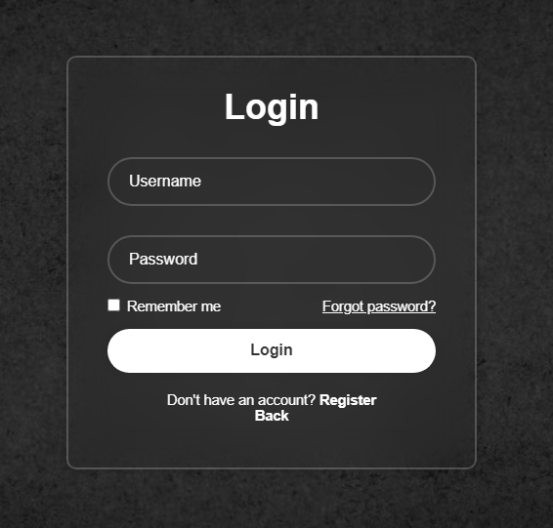

1. Login Page:

* Allows users to access their account by providing a Username and a Password
* **Remember Me Checkbox**: Option to save login credentials for future sessions.
* **Forgot Password Link**: Helps users recover their account if they’ve forgotten their password.
* **Login Button**: Enables users to submit their credentials and log in to their account.
* **Register Link**: Redirects new users to the registration page to create an account.

## 

## CSS Style and Bootstrap usage:

1. Home page:

* Applied background colors
* Card Hover Effects
* Grid System for cards
* Header and footer

1. Parts Page:

* Card Styling using margins and padding
* Grid system
* Header and footer

1. Auction Page:

* Background color
* Card for Car Auction Items
* Used forms
* Header and footer

1. About Us Page:

* Background color
* Header and footer
* Grid system
* Table

1. Contact Us Page:

* Margin and padding
* Header and footer
* Grid System in Contact info
* Forms

1. Login Page

* Input field and login button
* Header and footer
* Margins and paddings

## 4. hyperlink

<https://knightzcreativity.free.nf/?i=1>

<https://github.com/Hamzay443/Hamzay443.git>

## 5. table of contribution

| **task** | **assigned member** | **contribution** |
| --- | --- | --- |
| Home page | hamza | made the home page for our website project |
| About us | Laith | made the about us page that includes our goal and the garage history |
| Contact us page | Shathan | made the contact us page that have (email, phone number, location) and a form to send a message |
| parts | hamza | made the parts page that includes car parts for sale |
| auction | hamza | made the auction page that have all the cars available in the auction |